AETHERIS: A Self-Sustaining Kuiper Belt Colony for Long-Term Human Civilization

Team members:

* Aityk Shyntas
* Alikhan Demeuov
* Alibek Rabil
* Irsen Pak
* Aldiyar Kuanyshev

Canadian International School

Competition: AEROO Space Settlement Competition 2025

League: Senior (Grades 10-12)

**Abstract**

AETHERIS is a concept for a fully autonomous space colony orbiting within the Kuiper Belt, approximately 30 to 45 AU from the Sun, designed to support a population of around 200,000 people for a period of about 80 years.

Drawing inspiration from the O’Neill cylinder model, our team has developed an adapted orbital design focused on long-term stability and human sustainability. The colony will utilize fusion-based power systems and a biogenerative life support cycle modeled after ESA’s MELiSSA program, ensuring closed-loop resource management and minimal external dependence.

The primary goal of AETHERIS is to create a scientifically related and ecologically sustainable framework for deep-space living; one that demonstrates the potential for self-sufficient human presence far beyond Earth. In the long term, this orbital habitat could serve as a strategic outpost for future exploration and expansion beyond the Milky Way.

**Introduction**

Deep space is the following stage of the evolution of human civilization. Although the Moon and Mars have been historically the most feasible frontier to colonize, the Kuiper Belt offers a far better and more viable option and prospective colonized frontier, a vast source of ice, volatile substances, and fuel of helium-3. Making an appearance on this planet would be the definitive break of mankind with the Earth, and space colonization would cease to be a survival process and would turn into a self-sufficient one.

AETHERIS, which translates to upper-atmosphere, is the symbol of renewal, power and transcendence. AETHERIS is unlike the traditional orbital complexes found in the inner Solar System, to be close to the depths of the Kuiper Belt (nearly seven billion km from Earth). This transforms it not only into a station but into the prototype of an autonomous human civilization that will support life, government, and culture to an experience that is more than eight decades without external help.

It is innovative in terms of its fusion-based geosystems and AI-run ecological networks as well as self-evolving social structure that can adapt independently. AETHERIS is a living organism, which creates its own energy, recycles the biosphere, makes a prudent use of resources, and upholds the universal values digitally educated and through participatory governance.

It is not merely an engineering success, but a kind of a civilizational experiment, a prototype of how humanity can live, develop, and prosper far beyond the planet. The article below outlines its orbital physics, structural design and closed ecological systems, all of which are aimed at the development of the entire self-sufficient society in the universe.

infrastructure, AETHERIS exhibits a total shift of reliance on the Earth to a self-sufficient civilization beyond it. The following paper describes its orbital design, its structural design and its closed ecology systems, all of which have been the blueprint of the independent future of humanity in the universe.

**Location and Orbital Parameters**

AETHERIS is positioned 45AU far away in the inner Kuiper Belt, where ice and helium-3 resources are the easiest to reach. The orbit was designed to reduce the interference with gravity, as well as to be stable in the long run.

* Type of orbit: circular (eccentricity around 0.05)
* Average distance: 45 AU
* Orbital period: ~300 Earth years
* Latitude: 3 degrees south of the ecliptic.

Communication delay with Earth is about 6 hours one way, which is acceptable for asynchronous research collaboration and data exchange. Small ion engines perform orbital corrections once per decade.

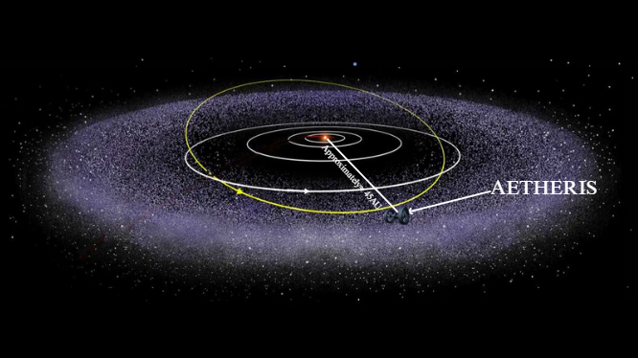

Figure 1. AETHERIS colony location in the Kuiper belt

**Structural Design and Artificial Gravity (Housing)**

The settlement is based on the concept of O’Neill, two-cylinder dual-cylinder, developed by NASA, and it is made out of two counter-rotating tubes that essentially cancel gyroscopic torque. Diameters of each cylinder are six kilometres, or radius of three thousand metres, and, to produce an artificial gravity of about 0.98 g on its interior surface, rotates at a rate of about 0.54 rpm and has a rotation period of about 111 seconds. This rate produces the appropriate level of gravity as well as ensures that Coriolis effects are negligible hence a habitable environment. The population in every cylinder maintains about one hundred thousand people. The outer hull is made of a composite of titanium and aluminum with regolith shielding, artificial daylight is provided by reflective mirrors to the concentric rings of agricultural activity. The main hub will be non-rotating and will be focused on zero-g laboratories and docking processes.

We divided AETHERIS into 6 life-needed sectors. We divided the spaceship into 6 sectors. Each sector has its own purpose, namely mining, reactor, housing, laboratory, food and livestock and water.   
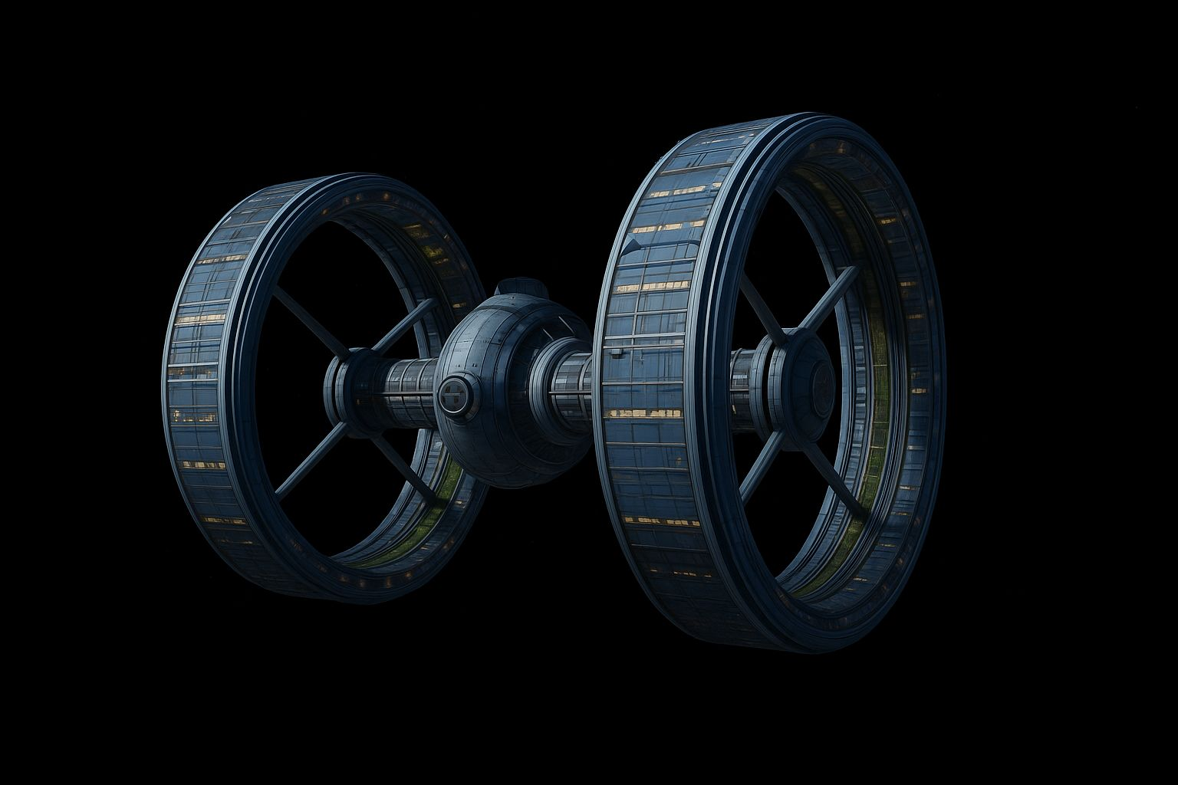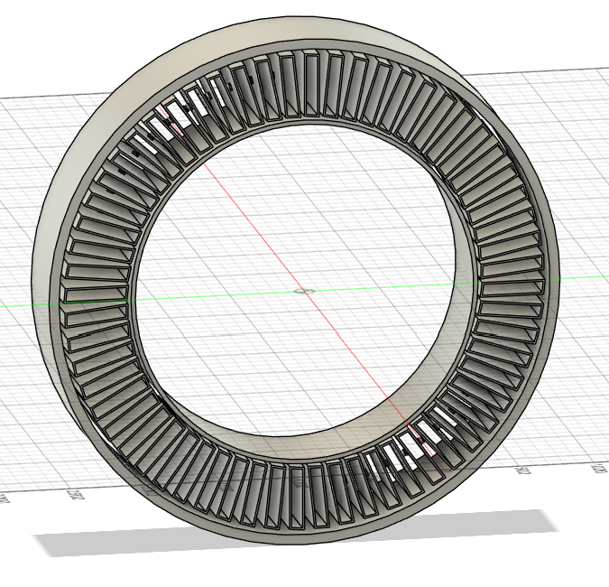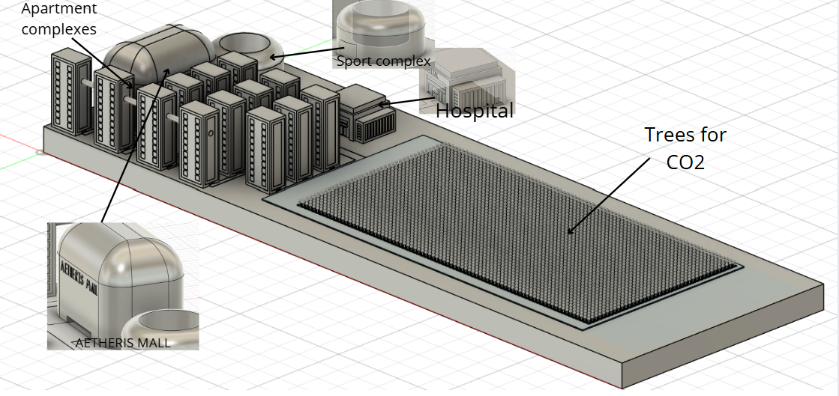  
Figure 2: Colony visualization  
Figure 3: Housing visualization  
Figure 4: Visuals of every part of housing sections

**Theoretical derivation and equations**

Gravity is produced by centripetal acceleration at radius r when the structure rotates with angular velocity ω(rad/s). The equations that come out are:   
ω = $2πƒ÷60$ $a=ω$ $r{}^{2}$
  
g = $a=ω$ $r{}^{2}$ 
The AETHERIS circular housing area will have a radius of 3000, to produce the same gravitational pull of Earth..  
 𝞈 $=\sqrt{g{}_{eff}÷r}$ 
 𝞈 = $\sqrt{9.81÷3000}$ $≈0.057rad/s$
Then we convert rotations per minute, we input the values  
 Rpm = ($0.057rad/s×$ 60) $÷2π$ $≈0.54rpm$
Therefore, at a rotational speed of 0.54rpm, the circular area produces a gravitational pull same as the earth.  
The AETHERIS housing industry is situated on the inside of the cylinder, as it is rotating, with the artificial gravity due to centripetal acceleration keeping the conditions near 1 g. This is to ensure that the residents are subjected to normal physiological conditions like that of the Earth limiting muscle and bone loss in the long-term habitation. The housing blocks are planned to house about 1,600 people each in the form of small complexes of apartments, combined with necessary facilities like hospitals, sports centers, and community space. The use of green zones with prolific vegetation and trees is of significant environmental value they absorb the CO 2 and constantly produce oxygen in the biogenerative system of life support of the colony. These trees along with agricultural lands make up a consistent closed ecosystem that promotes air quality and food production. The hospital complex offers the conditions of high level of AI-assisted health care, radiation diagnostics, and preventive genetic screening, which guarantee health care and biosafety of the population. The recreational as well as educational facilities are evenly distributed to ensure social cohesion and physical well being. Altogether, the colony architecture allows maximizing the use of space, recreates the conditions on Earth with the help of artificial gravity, and fosters physical and mental sustainability of all inhabitants.

**Hazards and mitigation**

The risks of radiation, impacts of micro-meteoroid, system failures etc would be countered by layered shielding, by the presence of redundant life support systems and constant check by autonomous safety mechanisms.

**Life support systems**

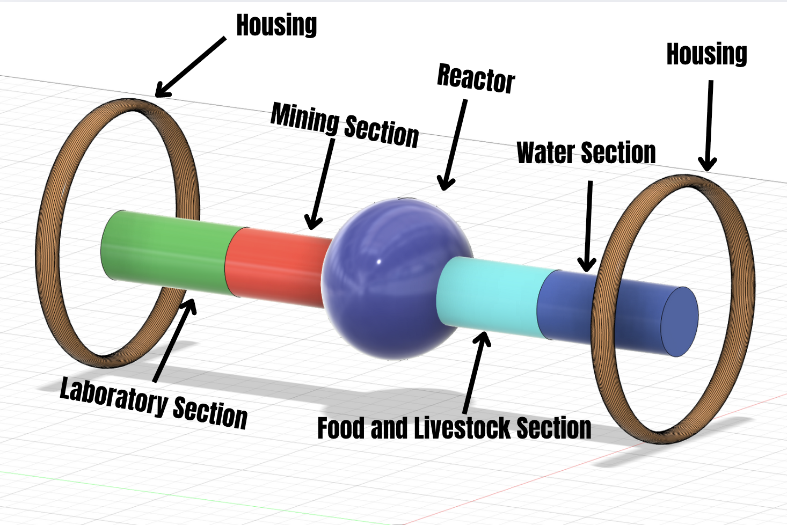

Figure 5: LSS (Life Support Systems) visualization of the colony

1. **Power and Energy Systems (Reactor)**

Because solar energy is so weak at 45 AU, AETHERIS's main energy source is nuclear fusion.

* Deuterium-Deuterium (D-D) fusion is the primary source.
* 500 MW of continuous power is the anticipated output.
* Fuel: Extracted from nearby icy Kuiper Belt bodies
* Supplementary: Mirror-based solar concentrators
* Backup: Modular fission reactor

Heat regulation is achieved through fusion-powered heat exchangers and large radiation fins. Power is distributed using superconducting maglev conduits to minimize possible losses.

mirrors to the concentric rings of agricultural activity. The main hub will be non-rotating and will be focused on zero-g laboratories and docking processes.

This sector will claim 100 000 $m^{2}$ in the central sphere.

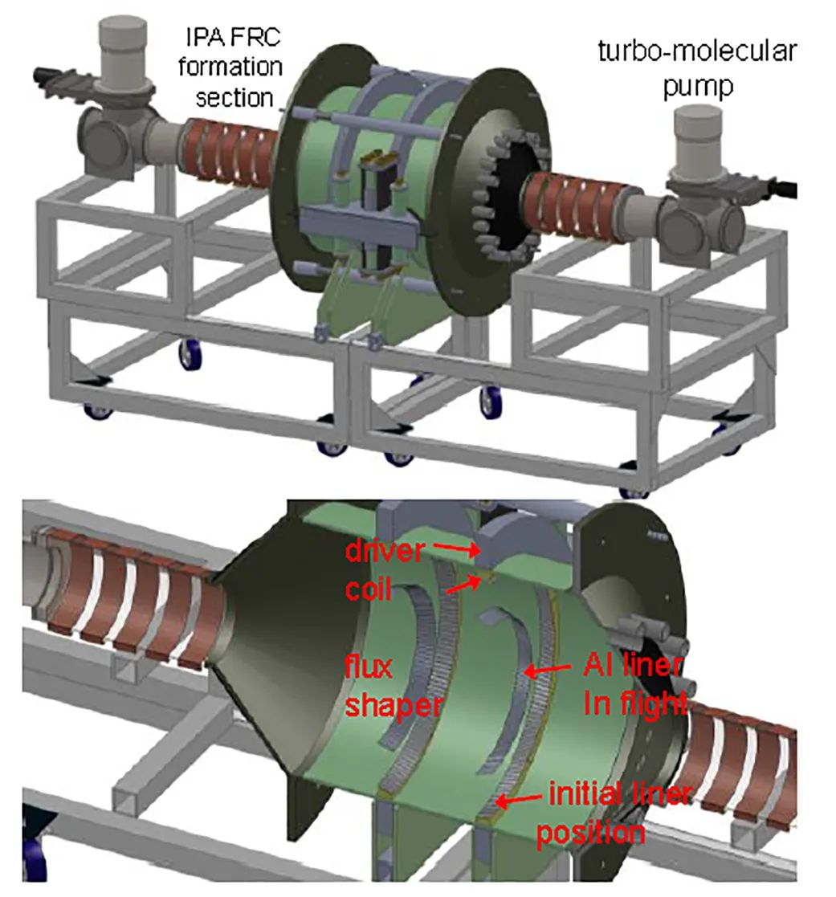

Figure 6: Fusion Energy Concept for Deep Space Missions (NASA, 2019)

1. **Mining Section**

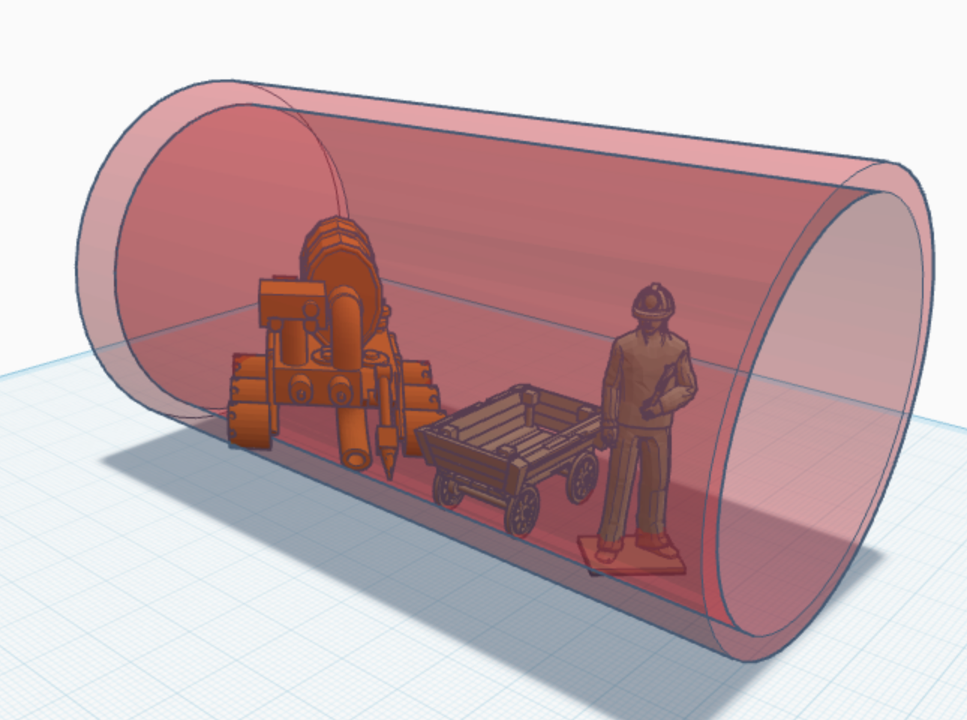

Figure 7: Visualization of Mining Section

We operate a fleet of approximately ten thousand autonomous unmanned aerial vehicles for mining in a wide belt of small icy bodies. Each drone lands, anchors, and drills 5-20 meters below the surface to reach pure, volatile-rich ice, using microwave techniques to process low-density regolith and thermal drilling to obtain denser ice mixtures.

The extracted ice is never exposed to vacuum - it is immediately placed in airtight cryogenic tanks kept at a temperature of 90-100 K, which prevents sublimation and preserves the content of volatile substances.

About 100 $m^{3}$ material is carried by each drone throughout a flight. The size of the fleet and a well-defined work schedule guarantee a continual and steady supply of materials to the central processing centre, even though each unmanned aerial vehicle only makes roughly four flights annually.

These resources would be observed by scientists in laboratories of the colony, results of which will be sent to the Earth for further observations. The area that given for the sector is 27 800 000 $m^{2}$.

1. **Water Producing Section**

AETHERIS uses a bioregenerative closed-loop ecosystem, modeled after the ESA MELiSSA Project, integrating plants, bacteria and algae for air and water recycling.

Water production at AETHERIS is carried out using a special machine with a drill and a tank next to it. Workers in the Mining Sector extract ice and send it to the Water Production Sector, where drilling, melting and water purification takes place. Here, the water is filtered and prepared for the colony's residents, plant irrigation and livestock breeding.

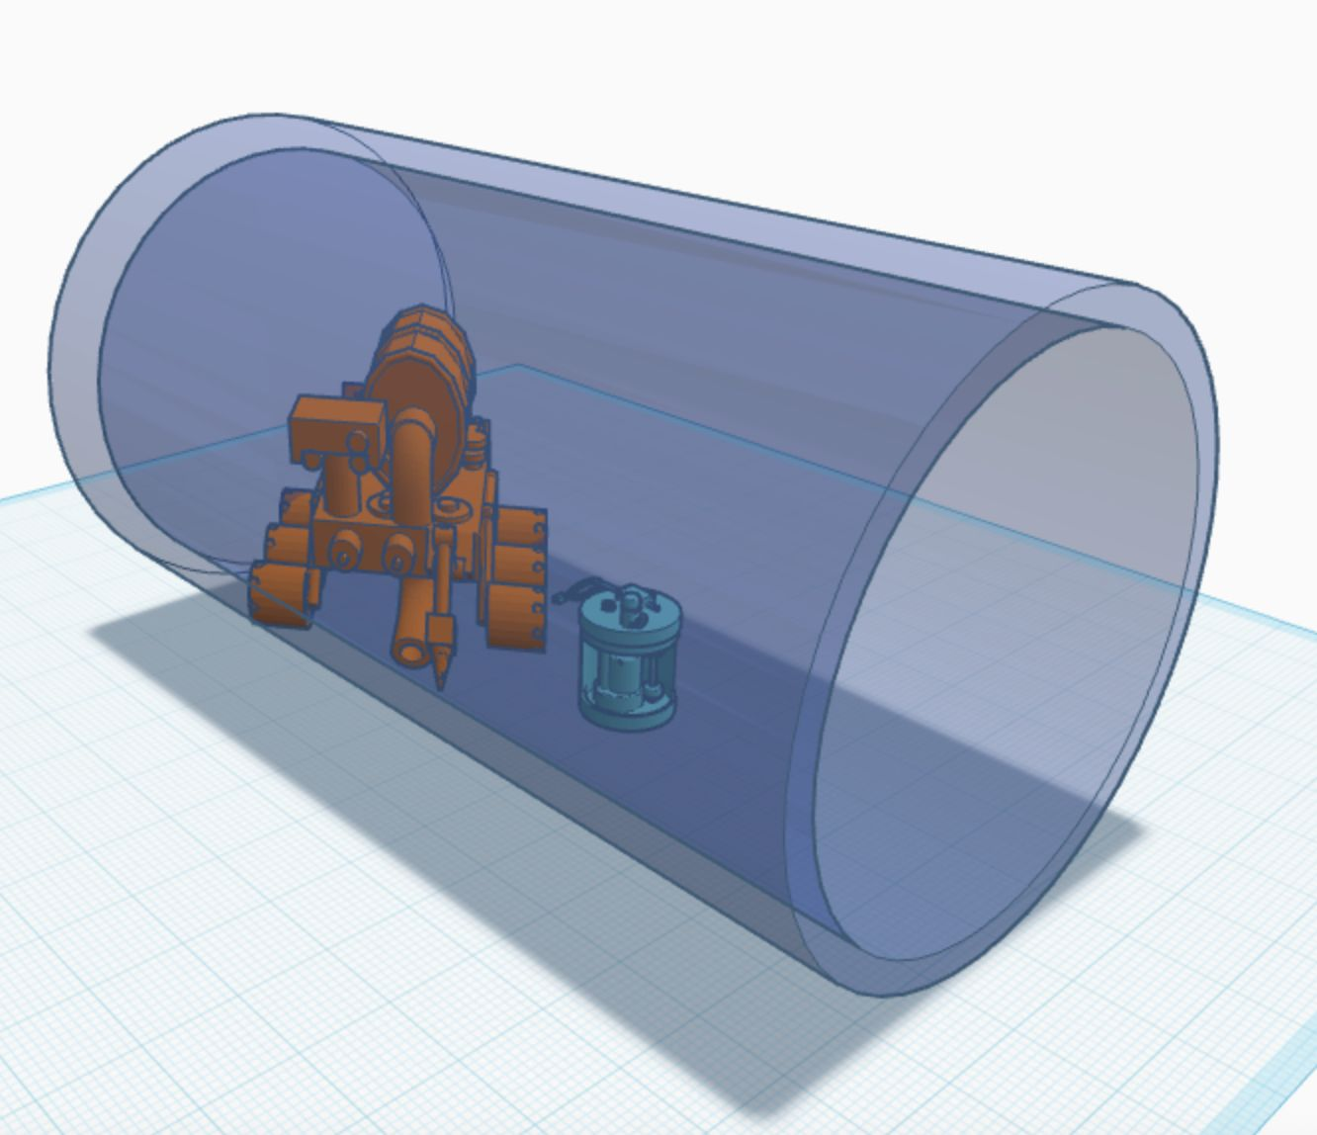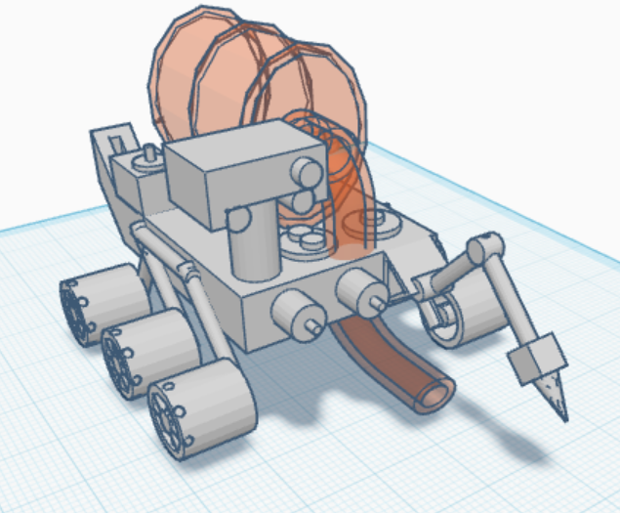

Figure 8: Visualization of Rover

Figure 9: Visualization of Water Producing Section

Adapted rovers capable of extracting ice from the Kuiper Belt deposits are used to produce water directly in space. Because this region is rich in ice, the rovers transport it to special AETHERIS stations, where it is converted into clean drinking water. This system provides the colony with a stable water source and supports Biodiversity within a closed ecosystem.

For this sector will be allocated 27,800,000 $m^{2}$ of Area.

1. **Agricultural and Livestock Section**

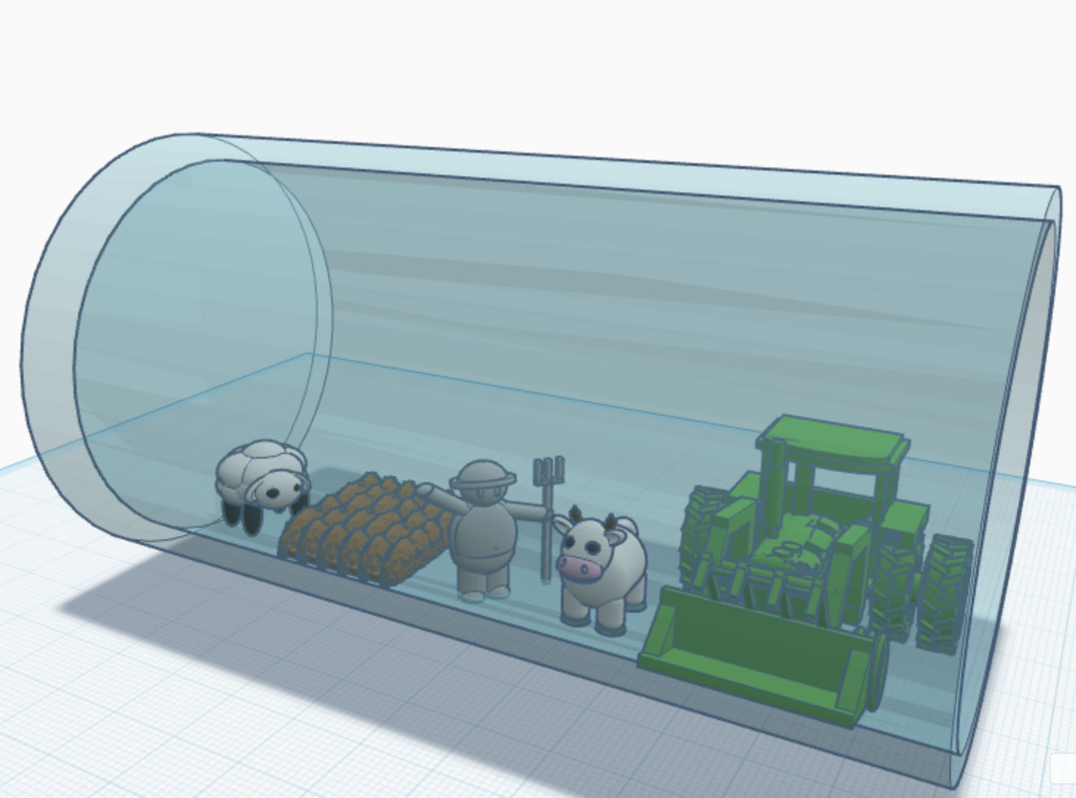

Figure 10: Visualization of Agricultural and Livestock Section

In this section, there will be food production and livestock breeding. This sector is key to preserving the life and further prosperity of the colony. In this section, people will be engaged in agricultural activities, we will also use livestock such as sheep, cows, and chickens. This is done in order not only to support civilization with food, but also with the supply of various materials, using wool, feathers and so on.

The population of the colony is approximately 200 000 and the average number of calories/day is 2500 and the daily average calorie/year is 912500 per person and we have the total number of $\frac{912 500}{200 000}$ = 182 500 calories/year, that is $\frac{182 500}{100 000}=1825$. In an attempt to make such a caloric intake, the food is categorized:

Cereals 50%

Legumes and protein plants 15%

Vegetable and fruits 10%

Vegetable fat 10%

Animal products 15%.

Wheat, soybeans, potatoes, lettuce, tomatoes, bamboo, and spirulina are some of the main types of plants. These crops supply the station's contained atmosphere with oxygen in addition to food. Spirulina serves as a source of protein and oxygen reserve under increased stress.

To cover the colony's annual needs, it requires:

* wheat about 16,000 tons,
* potatoes about 47,000 tons,
* fruits and vegetables about 45,000 tons,
* spirulina about 400 tons.

Animal husbandry involves the breeding of sheep, cows, and poultry. It has approximately 96,000 chickens, which yield 48 million eggs in a year. It has about 100 bulls and 1000 cows that yield about 6 million litres of milk annually. Approximately 4000 to 6000 sheep will allow you to have wool and meat constantly supplied to your home.

The agricultural industry occupies about 27,800,000 square meters of land that comprises fields, hydroponic farms, livestock facilities, warehouses, and spirulina bioreactors.

Soybean vegetable fats with an oil production of 18%(10% = 18.25 billion kcal):

* Soybeans required: 11,470 tons/year
* We get oil: 2,064 tons/year (covers 10% of calories)
* Soy cake/flour: 9,406 tons/year covers the main share of the legumes and proteins together with spirulina.

Animal husbandry (minimum resources, stable output)

* Chickens (eggs): 240 eggs/person * year = 48 million eggs/year.
* Milk and other supplies: 30 liters/person * year = 6 million liters/year.
* Sheep (meat + wool): 4-6 thousand heads for cyclic slaughter/wool.
* Meat (total): 600-1,000 tons/year

Oxygen and biodiversity

* The main production of O₂ is provided by leafy and tomato;
* Spirulina is an O₂ buffer and a high-protein supplement;

27,800,000 $m^{2}$ area will be designated for this sector.

1. **Laboratory Section**

The minerals we extracted using rovers will be studied in a laboratory section. This section will store samples found in space. Additionally, there will be a Life Support Systems Laboratory to monitor water and air purity and Medical Laboratories to monitor the health of the 200,000 residents and protect against radiation.

There will be given 27,800,000 $m^{2}$ area for this sector.

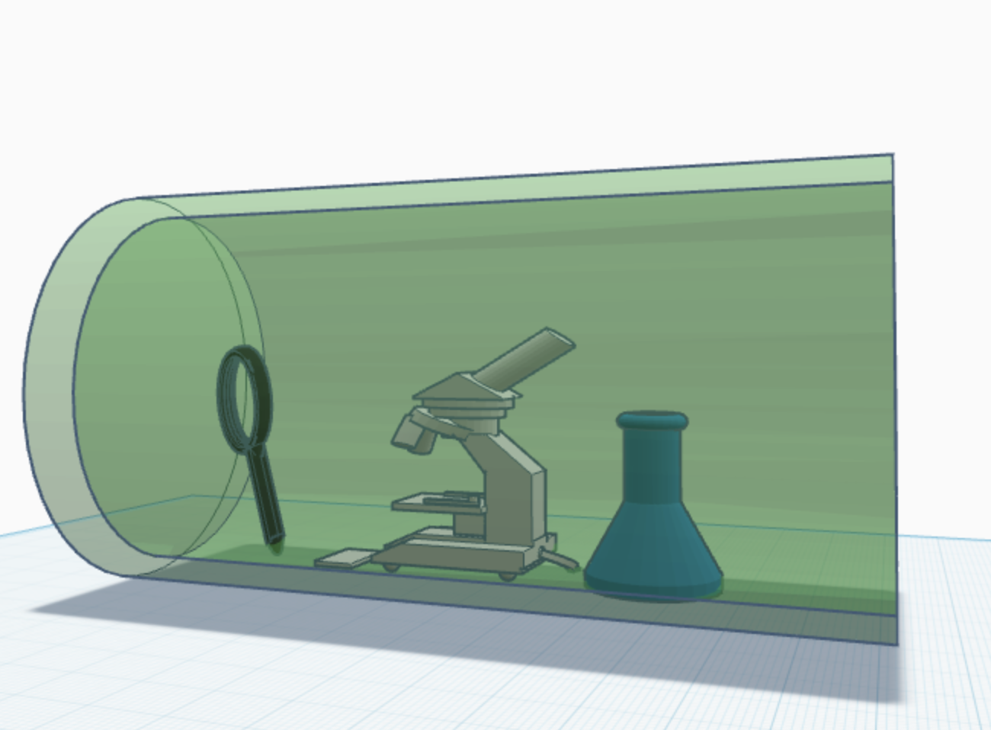

Figure 11: Visualization of Observation Section

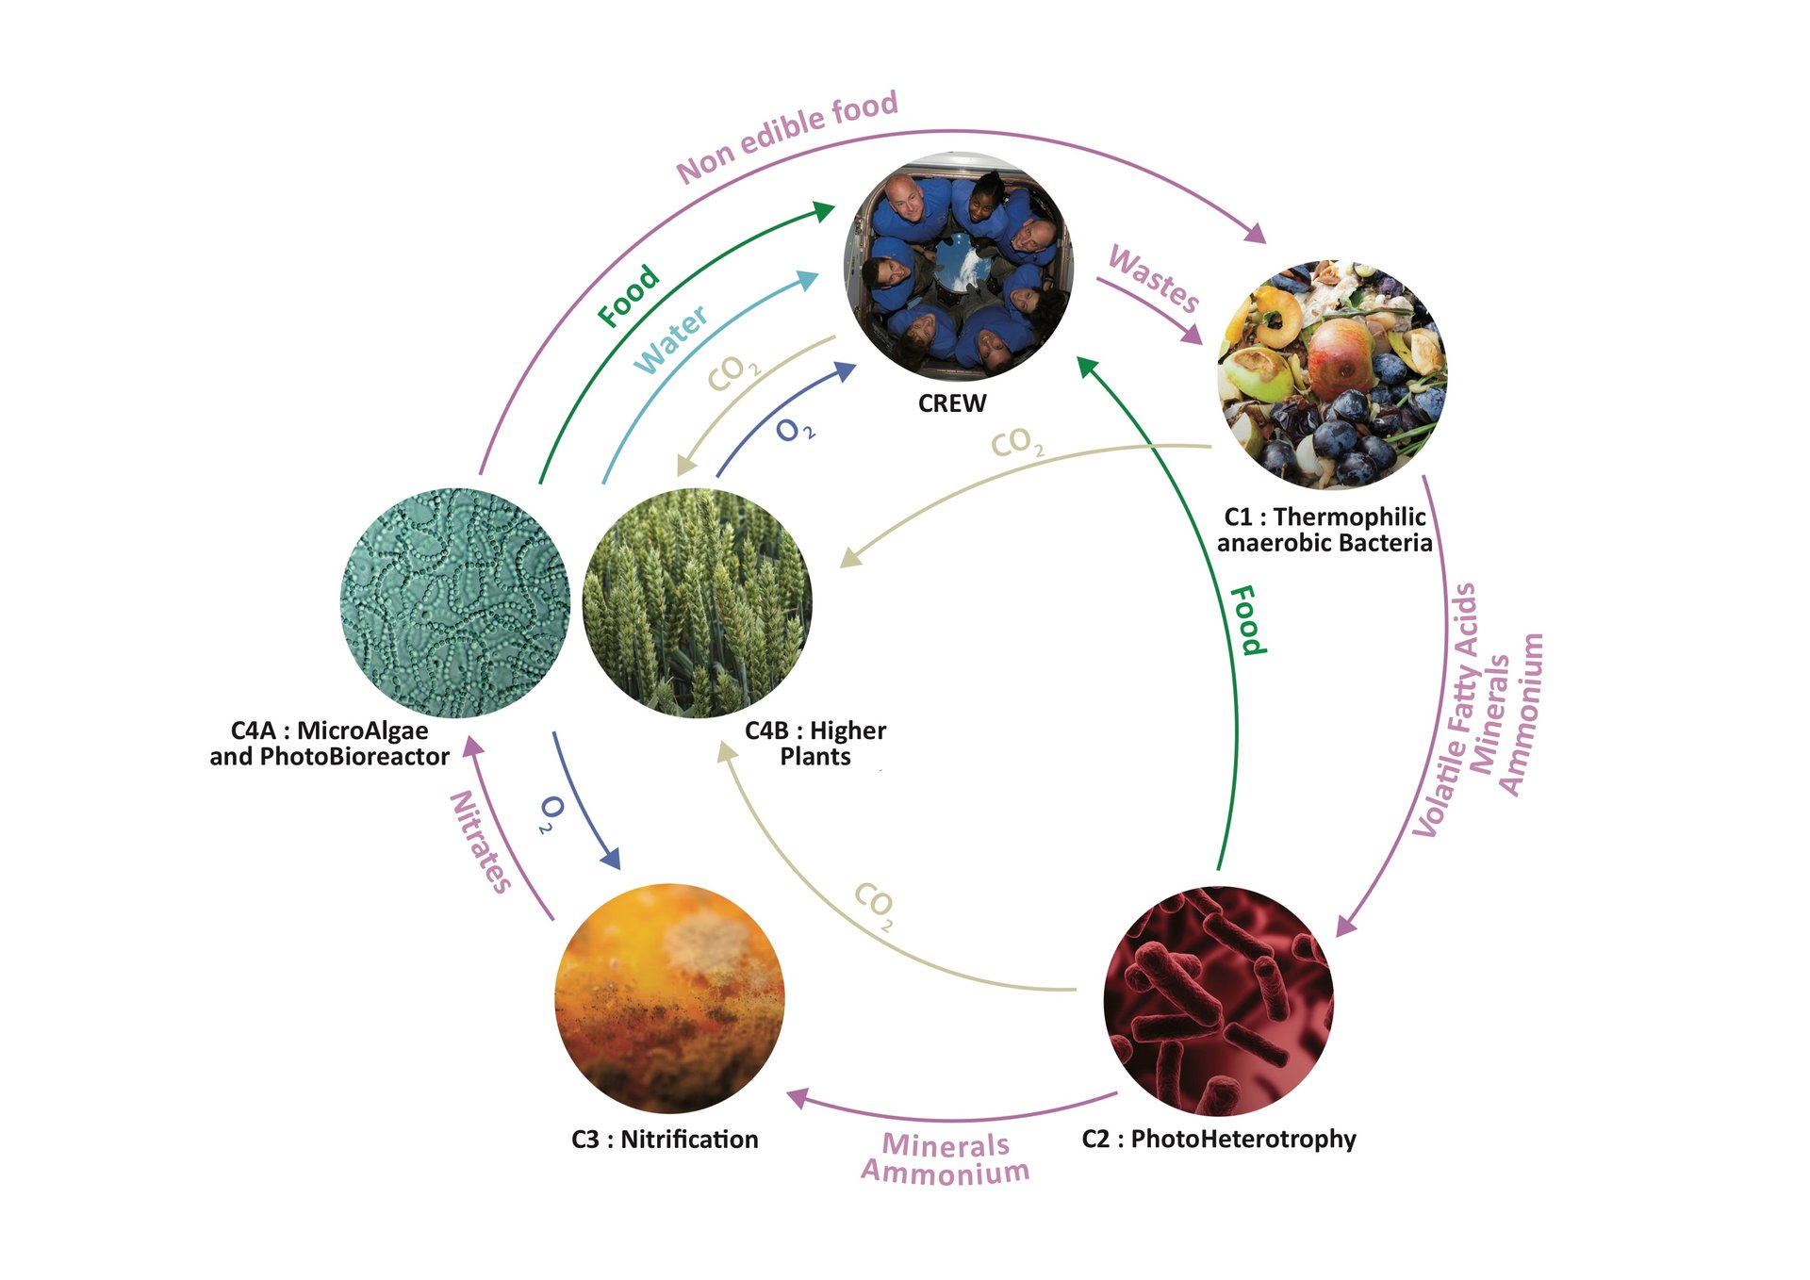Figure 12: ESA MELiSSA Ecosystems Diagram

**Engine**

The propulsion of the AETHERIS colony would be based on the use of a series of high efficiency ion and plasma propulsion systems at each end of the structure. The engines are not intended to AETHERIS at high speeds but to make long-term orbital corrections and stabilisations in the Kuiper Belt. Ionized xenon or helium-3 would be used in each thruster that is rich in the adjacent area, which would give a soft but continuous push with minimal use of fuel. Attitude control jets and gadgets of the gyroscopic type would ensure that the cylinders are perfectly tilted and that they counter rotational drift. The colony would turn on its fusion-boost propulsion modules to carry out significant repositioning (such as altering orbit or avoiding debris). Bursts of high power could be produced by these modules directly out of the main refuelling colony, which would be used to supply energy to all the propulsion systems through the fusion core in the colony, and avoid the use of external refuelling. A combination of these mechanisms allows AETHERIS to remain stationary over hundreds of years with enough manoeuvrability to undertake course corrections, station-keeping and controlled reorientation to achieve the best solar orientation.

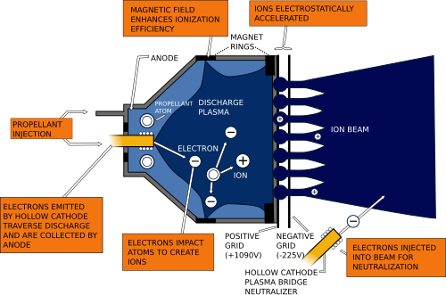  
Figure 13: Ion thruster - Wikipedia

**Resource Extraction and Transportation**

Mining operations are robotic and fully autonomous, operated by AI-controlled cargo drones.

Mining Process:

1. Identify ice-rich or helium-3 bodies using infrared mapping
2. Land autonomous drilling units
3. Extract ices and gases
4. Store cryogenically
5. Return via low-thrust plasma tugs

Average resource mission duration: 1-3 years.

**Social & Cultural Systems**

AETHERIS is designed for long-term human life, not just survival. Society is organized around education, science and creativity.

* Population: 200,000
* Government: Hybrid democracy
* Healthcare: AI-based diagnostics, radiation protection and genetic screening
* Culture: Virtual museums, art centers, sports and zero-g arenas

Each resident has 20 m square personal space and access to public spaces under artificial gravity.

**Education**

Education will start in early childhood and it will follow a flexible lifelong plan. The majority of classes will be held in interactive digital settings and virtual labs rather than traditional classrooms, where students can learn physics, biology, and engineering ideas through space-related simulations. Subjects like astro-engineering , environmental management, robotics and psychology would be central, preparing young people for maintaining the colony’s systems. Teachers and AI tutors would work together: human educators focusing on creativity, ethics and problem-solving, AI systems personalize learning pace and style. Higher education would operate through research hubs linked with Earth universities, which allows exchange of data and discoveries. Scholarships and internships would encourage every student to apply knowledge in real colony operations, for instance, by helping maintain life-support farms or designing improvements to recycling systems.

* Primary (3-12 years): There are approximately 20 primary schools in which 2,000-2,500 children are enrolled.
* Secondary school (13-18 years): The country has approximately ten secondary schools with a population capacity of 2,000 students with their emphasis being on science, languages, and practical training.
* Higher education and research: There are one basic university complex with four to five special institutes (space engineering, biology and life sciences, medicine, and social sciences) with a population of 10,000-15,000 students.
* Eight to ten technical and vocational schools are responsible for offering training on robotics, agriculture, maintenance, and resource management.
* Adult Education and retraining centres; five or six professional development and lifelong learning open centres.

**Judging system**

The colony will elect a council representing various sectors: science, engineering, the environment, healthcare, and social welfare. Beneath it, local community courts would handle daily issues such as disputes, resource usage and safety violations. For major cases, a central judiciary board composed of both human judges and AI advisors would ensure balanced decisions, using data in order to prevent bias however the final judgement would be on people. Laws would prioritize sustainability, equality and safety. Public meetings and digital voting platforms would allow citizens to participate directly in making policies. This combined system of education that grows capable thinkers and a judicial system that protects justice and cooperation would form the foundation of a stable and ethical space society.

**Environmental Impact and Waste Management**

The colony maintains zero external waste emission. Every material is either recycled or repurposed.

* Organic waste:fertilizer
* Bioplastic waste: construction material
* CO2-neutral atmosphere via microbial loops and algae
* Space debris protection through magnetic collectors

The environment cycle of AETHERIS is entirely closed, making it an example of sustainable off-world living.

**Innovations and Scientific Justifications**

* Magnetic Shield Layer is superconducting coils for cosmic radiation protection, it based on NASA Langley (2021)
* Eco-Regulation is neural network for predicting oxygen and nutrient balance, it based on ESA MELiSSA (2019)
* Fusion Heat Management is thermal control via plasma radiators and it based on NASA Fusion Studies (2019)
* Genetic Adaptation is modified crops to grow under low sugar flux, it based on ESA Biogenetics Program
* Autonomous Mining is robotic fleets for He-3 extraction, it based NASA ASTRA Program

**Conclusion**

AETHERIS shows that a sustainable, independent human society beyond Mars is feasible with the aid of contemporary and developing technologies.

Fusion energy, closed ecosystems and advanced robotics combine to create a self-sufficient colony that can survive in the solar system's most isolated regions.

It represents a future where humanity and technology coexist sustainably- even 7 billion kilometers from Earth.

**Resources**

1. [NASA Ames Research Center. Space Settlements: A Design Study. 1976](https://ntrs.nasa.gov/citations/19770014162).  
2. [ESA MeliSSA Foundation. Micro-Ecological Life Support System Alternative. 2019](https://www.melissafoundation.org).

3. [NASA Langley Research Center. Active Magnetic Shielding for Space Radiation Protection. 2021](https://www.nasa.gov/wp-content/uploads/2017/07/niac_2012_phaseii_westover_radiationprotectionandarchitecture_tagged.pdf?emrc=4e9d26).

4. [JPL. Kuiper Belt Science Overview. NASA Solar System Exploration, 2022.](https://science.nasa.gov/solar-system/kuiper-belt/)

5. [National Research Council. Artificial Gravity Studies. 2019.](https://ntrs.nasa.gov/api/citations/20205005149/downloads/Artificial%20Gravity%20Student%20Presentation.pptx.pdf)  
6. [NASA Technical Reports. Fusion Propulsion and Power Concepts for Deep Space. 2019.](https://ntrs.nasa.gov/citations/20020024084)

7. Figure 2 was visualized with assistance from ChatGPT, OpenAI. (2025)(Feb 13 version) [Large Language Model]. https://chat.openai.com

8. [Ion Thruster- Wikipedia](https://en.wikipedia.org/wiki/Ion_thruster)  
9. [What Is The Kuiper Belt? A Guide To The Outer Solar System](https://www.skyatnightmagazine.com/space-science/what-is-kuiper-belt-outer-solar-system)